Moraine Civic Center
3050 Kreitzer Road, Moraine, OH

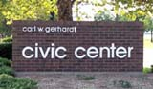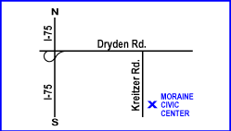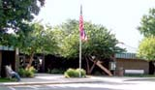
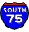 | Take I-75 S. | 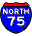 | Take I-75 N.
 | Take the DRYDEN RD SOUTH exit- EXIT 50A- toward MORAINE. |  | Take the DRYDEN RD exit- EXIT 50A.
 | Merge onto DRYDEN RD. |  | Take the DRYDEN RD SOUTH ramp.
 | Turn RIGHT onto KREITZER RD. |  | Turn RIGHT onto DRYDEN RD.
 | Moraine Civic Center will be on the left. |  | Turn RIGHT onto KREITZER RD.
 |  |  | Moraine Civic Center will be on the left.

